# Hospital Management System

* Entities: Patient, Doctor, Appointment, Room.
* Relationships: Patient 'makes' Appointment, Appointment 'is with' Doctor, Patient 'assigned to' Room

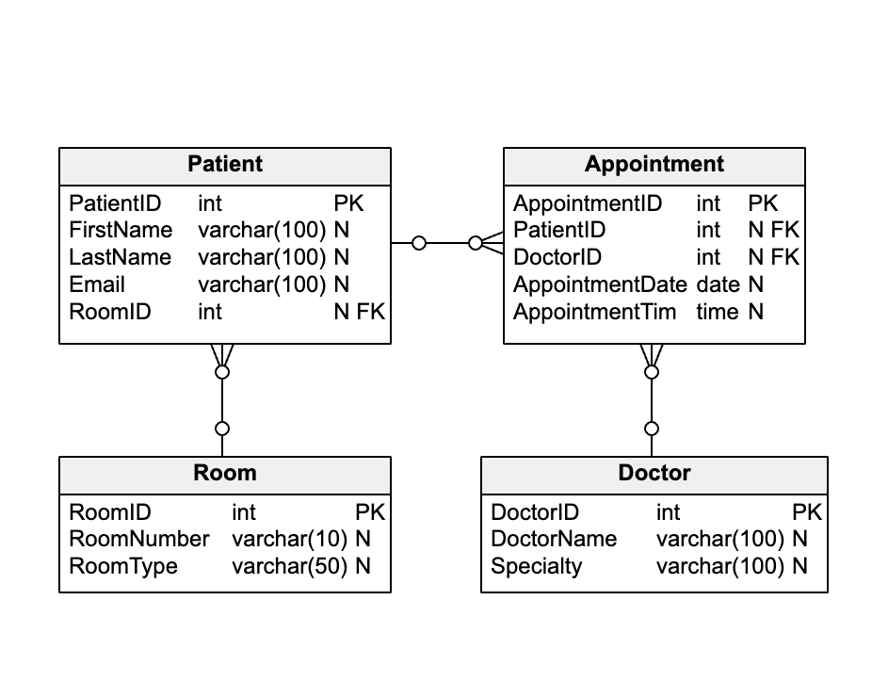

## In this schema:

* The Patient table represents the patients who make appointments and are assigned to rooms. Each patient is assigned to a room, which is represented by the foreign key RoomID.
* The Doctor table represents the doctors with whom patients make appointments.
* The Room table represents the rooms to which patients are assigned.
* The Appointment table represents the appointments made by patients. Each appointment is associated with a patient (who made the appointment) and a doctor (with whom the appointment was made). These are represented by the foreign keys PatientID and DoctorID. The AppointmentDate and AppointmentTime fields represent the date and time of the appointment.

## Questions :

Create a simple console app using efcore and any sql db, create relevant relationships and do CRUD OPERATIONS.